Kindergarten Supply List
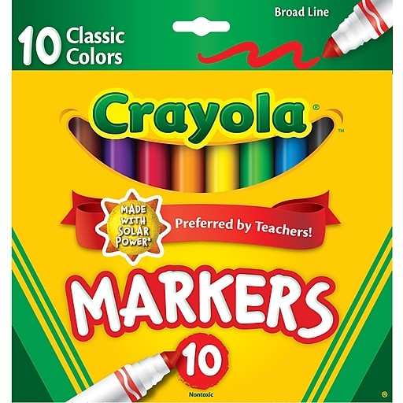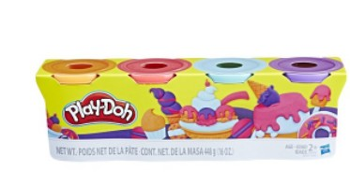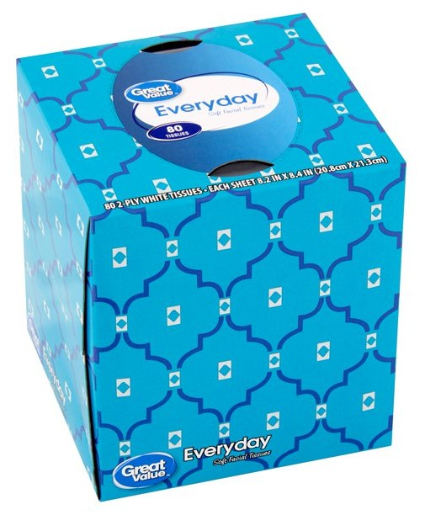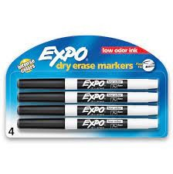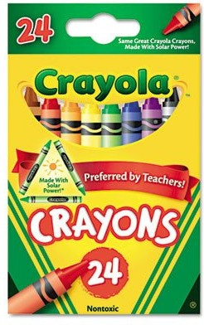

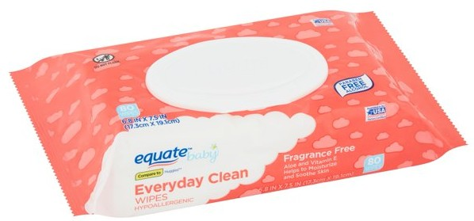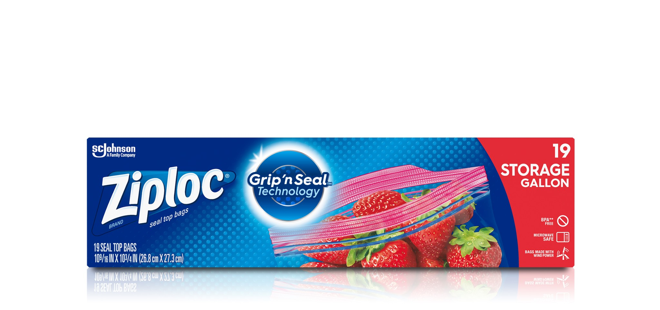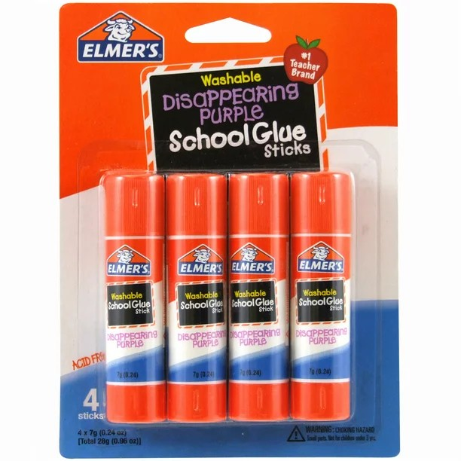
2 packs of Crayola 24 color crayons

2 packs of Crayola broad line markers classic colors

1 pack of 4 color Play-Doh

Four Black Expo Low Odor Dry Erase Markers-thin fine point

Four Elmer’s Glue Sticks One package of Baby Wipes One box of tissues
Ziploc Baggies (girls-gallon size boys-quart size)

One pair of child size headphones
(labeled in a bag with your child’s first and last name)

***Additional Items May Be Requested By Your Child’s Teacher***

